Design Documentation

Version 1.0

January 30, 2020

EFFICIENT INTEGRITY CHECKING AND SECURED DATA

SHARING IN CLOUD COMPUTING

PROJECT GUIDE:

S.SUSHMA PROJECT ASSOCIATES:

Assistant professor U.VARALAKSHMI (16A91A1250)

IT Department G.AJAY TEJA (16A91A1217)

K.L.V.SAMYUKTHA (16A91A1227)

A.MADHU PRIYA (16A91A1202)

**SYSTEM DESIGN**

In our project, we are using the detailed system design. Here we have user, owner, attribute authority and certificate authority. Certificate authority present in cloud which authorizes user, owner and attribute authority. Data owner uploads files in the cloud, certificate authority verifies and generate private key to the files. Users send requests to certificate authority to download files. Attribute authority receives those requests and sends to certificate authority, it verifies user id and attribute authority request and send files and key to attribute authority. Now attribute authority sends secret key to user, once the user access the key, then files can be viewed.

Remote data integrity checking (RDIC) enables a data storage server, to a verifier that it is actually storing owner’s data honestly.

**3.2 DATA DICTIONARY**

After carefully understanding the requirements of the client the entire data storage requirements are divided into tables. The below tables are normalized to avoid any anomalies during the course of data entry.

|  |  |  |  |
| --- | --- | --- | --- |
| **Field Name** | **Data Type** | **Description** | **Constraints** |
| Id | Int(10)unsigned | Id of user or owner | Unique, Not Null auto-increment |
| Name | Varchar(45) | Name of the user | Not Null |
| Pass | Varchar(45) | Password of user | Not Null |
| email | Varchar(45) | Email id of user | Not Null |
| Dob | Varchar(45) | Date of birth of user | Not Null |
| Gen | Varchar(45) | Gender of user | Not Null |
| Role | Varchar(45) | Role of user | Not Null |
| State | Varchar(45) | State of the user | Not Null |
| Country | Varchar(45) | Country of the user | Not Null |
| Status | Varchar(45) | Status of user | Not Null |

Table 3.2.1Database Table for Registration

|  |  |  |  |
| --- | --- | --- | --- |
| **Field Name** | **Data Type** | **Description** | **Constraints** |
| Id | Int(10)unsigned | Id of user or owner | Unique,Not Null auto_increment |
| Name | Varchar(45) | Name of the user | Not Null |
| Email | Varchar(45) | Email id of user | Not Null |
| State | Varchar(45) | State of the user | Not Null |
| Country | Varchar(45) | Country of the user | Not Null |
| Secretkey | Varchar(45) | Secret Key | Not Null |
| Status | Varchar(45) | Status of the user | Not Null |

Table 3.2.2Database Table for Request

|  |  |  |  |
| --- | --- | --- | --- |
| **Field Name** | **Data Type** | **Description** | **Constraints** |
| Id | Int(10)unsigned | Id of user or owner | Unique,Not Null auto_increment |
| Filename | Varchar(45) | Name of the file | Not Null |
| File | Varchar(45) | Type of file | Not Null |

Table 3.2.3Database Table for File_Upload

|  |  |  |  |
| --- | --- | --- | --- |
| **Field Name** | **Data Type** | **Description** | **Constraints** |
| Id | Int(10)unsigned | Id of user or owner | Unique, Not Null auto_increment |
| Filename | Varchar(45) | Name of the file | Not Null |
| Username | Varchar(45) | Username of user | Not Null |
| Time | Varchar(45) | Time of uploaded file | Not Null |

Table 3.2.4Database Table for Download

**UML DIAGRAMS**

Unified Modeling Language is the language used to visualize, specify, construct and document any component of software engineering.

**Use Case Diagram**

**U**se case diagram shows a set of use cases and actors and their relationships.In this diagram, Data owner and Data users get registered in the cloud and login, Certificate authority authorizes owners, users and attribute authority requests and activates them. Data owner uploads files in the cloud, certificate authority verifies and generate private key to the files. Users send requests to certificate authority to download files. Attribute authority receives those requests and sends to certificate authority, it verifies user id and attribute authority request and send files and key to attribute authority. Now attribute authority sends secret key to user, once the user access the key, then files can be viewed.

**Actor**

Actor in ause case diagram is **any entity that performs a role**in one given system. This could be a person, organization or an external system and usually drawn like skeleton.

**Use Case**

A use case **represents a function or an action within the system**. It is drawn as an oval and named with the function.

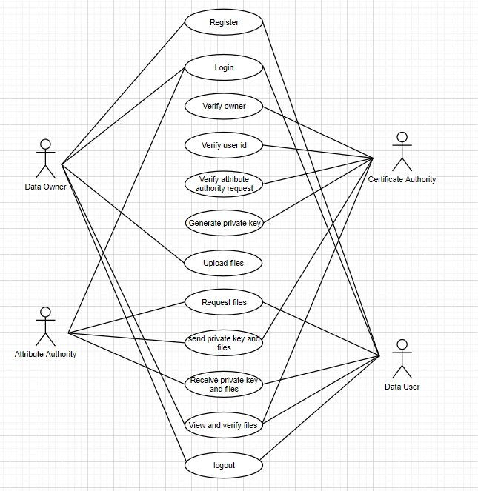

Use Case Diagram

**Class diagram**

A class diagram shows a set of classes, interfaces, and collaborations and their relationships.In our class diagram we have Data owner, Data user, Attribute authority, Certificate authority as main class and its operations are classified as sub classes. Here Data owner has 2 attributes (Register, Login), 2 operations (Upload files, View files).

Data user has 2 attributes(Register, Login), 2 operations (View files,Send requests to certificate authority).Certifcate authority has 5 operations(Verify owners, Verify user id, Verify attribute authority request, Generate private key, Send files and key to attribute authority).Attribute authority has 1 attribute(Login), 4 operations(View user’s request,Send request to certificate authority,Receive files and key from certificate authority,Send files and key to user).

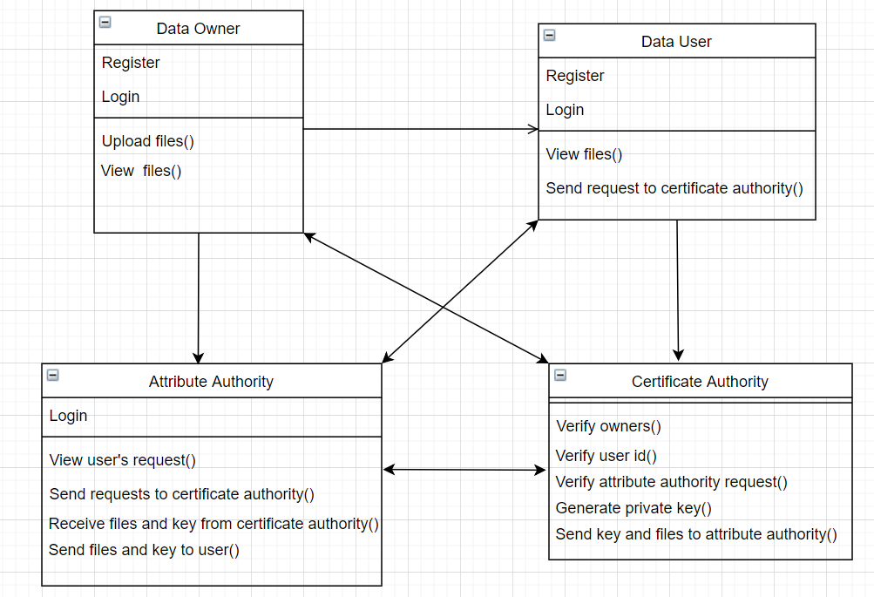

Class Diagram

**3.3.3 Sequence Diagram**

A sequence diagram shows a set of objects and the messagessent and received by those objects. In sequence diagram we have four objects as Data owner, Data user, Attribute authority, Certificate authority. In this, firstly Data owner and Data user registers in the cloud and owner logins. Certificate authority present in the cloud authorize owners, then owner uploads files in the cloud. Now user and attribute authority logins, user send requests to certificate authority for files and attribute authority take those requests and forward to certificate authority. Then certificate authority verifies attribute authority request and user id and send files and secret key to attribute authority. Attribute authority receives files and key and forwards those to user.

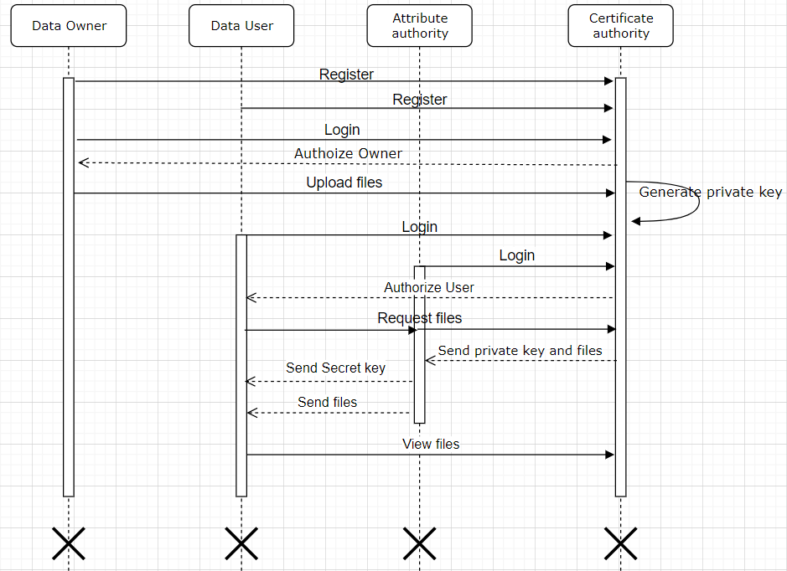

Sequence Diagram

3.3.4 Collaboration Diagram

Collaboration Diagram is an interaction diagram that emphasizes the structural organization of the objects that send and receive messages. Sequence diagrams and collaboration diagrams are isomorphic, meaning that you can take one and transform it into the other.

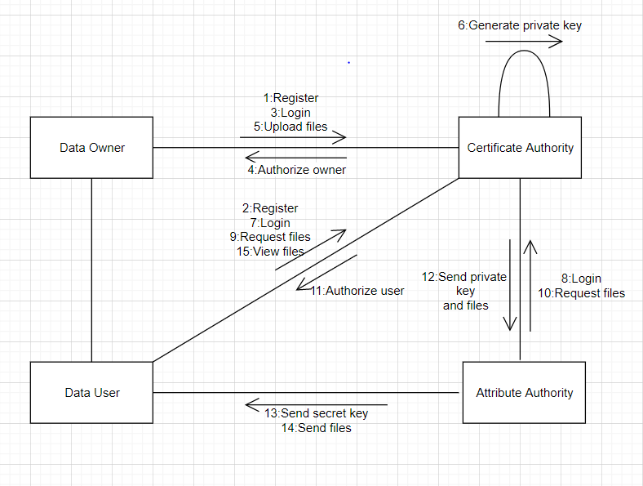

Collaboration Diagram

**3.3.4 Activity Diagram**

An activity diagram is a special kind of a state chart diagram that shows the flow from activity to activity within a system. Here for Data owner side the owner will register and logins in the cloud. Certificate authority authorizes owners, then owner upload files and view them. For Data users it registers and login in the cloud and requests certificate authority for activation. After activation, it send requests to download files. Receives files and key from attribute authority and can view files. For Attribute authority, it logins and view requests from user and then forward them to certificate authority. Certificate authority verifies user then send files and secret key to attribute authority. For Certificate authority, it authorize owners, users and attribute authority. It activates user and attribute authority, then view requests from attribute authority and send files and key to it.

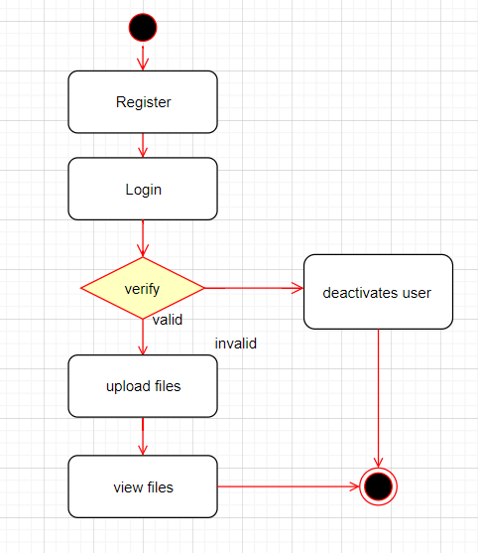

Activity Diagram for Data Owner

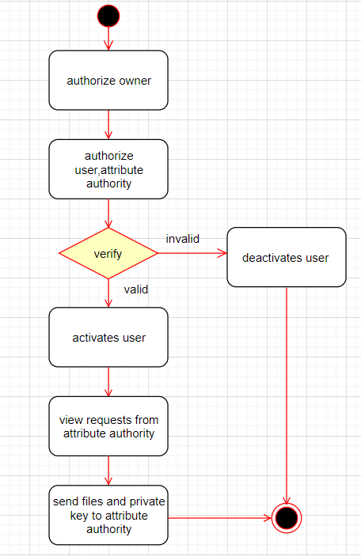

Activity Diagram for Certificate Authority

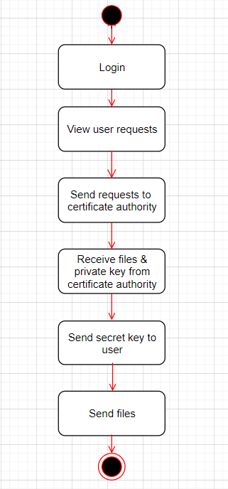

Activity Diagram for Attribute Authority

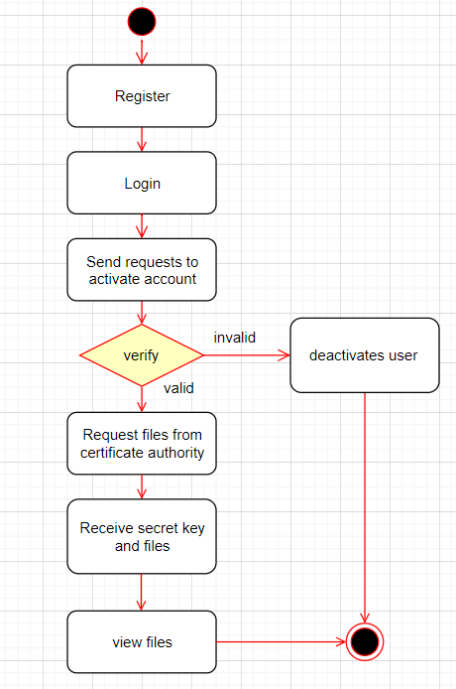

Activity Diagram for Data User.